SALES DASHBOARD CASE STUDY
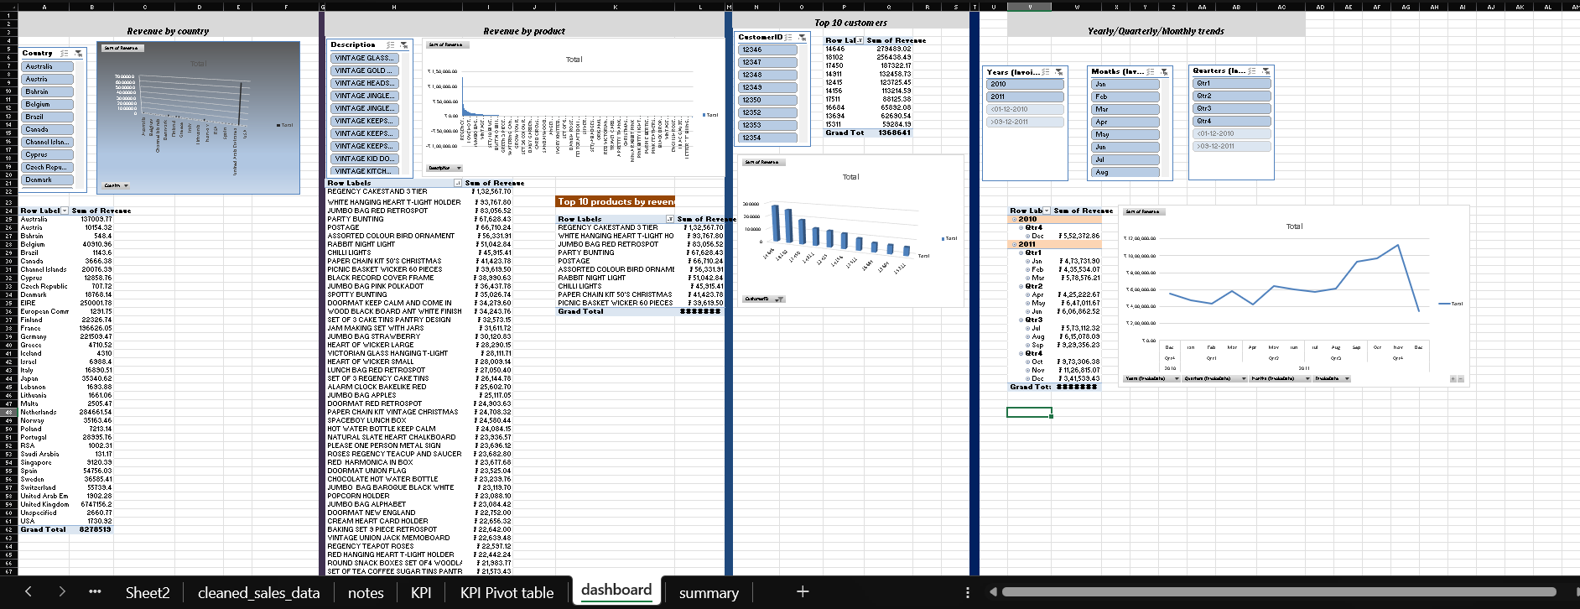

Introduction:

- This project analyzes a retail sales dataset to identify revenue drivers, top customers, and sales trends. The goal was to build a recruiter-friendly Excel dashboard showcasing key KPIs

Workflow:

Data Cleaning → handled duplicates, missing values, formatted dates.

Pivot Tables → built KPIs for revenue, products, customers, and trends.

Dashboard → added Pivot Charts, slicers, and insights summary.

Key KPI’s:

- Revenue by Country → Identified top markets.

- Revenue by Product → Highlighted best-selling items.

- Top 10 Customers → Listed most valuable clients.

- Monthly/Quarterly Trends → Showed seasonality and growth.

Insights:
- United Kingdom alone contributed 81% of Revenue.
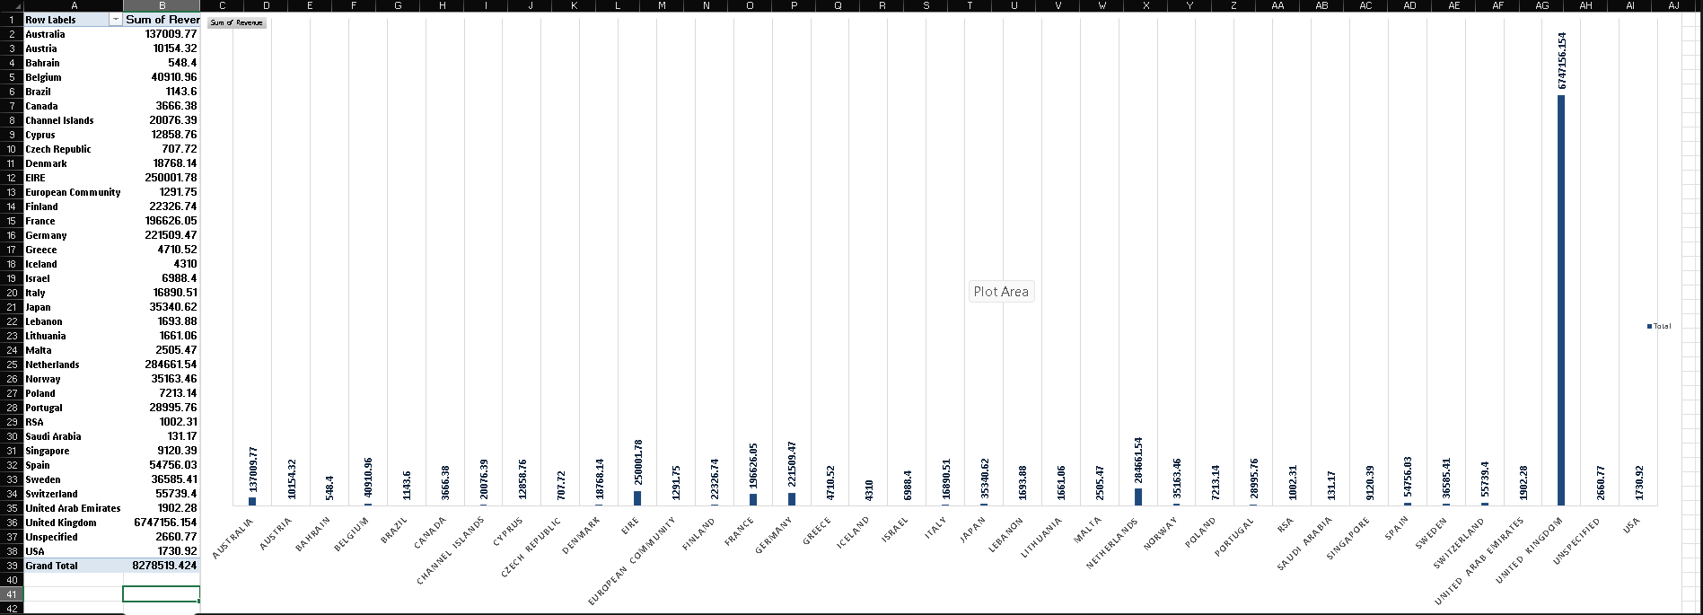

- Regency Cakestand 3 tier is top selling product.
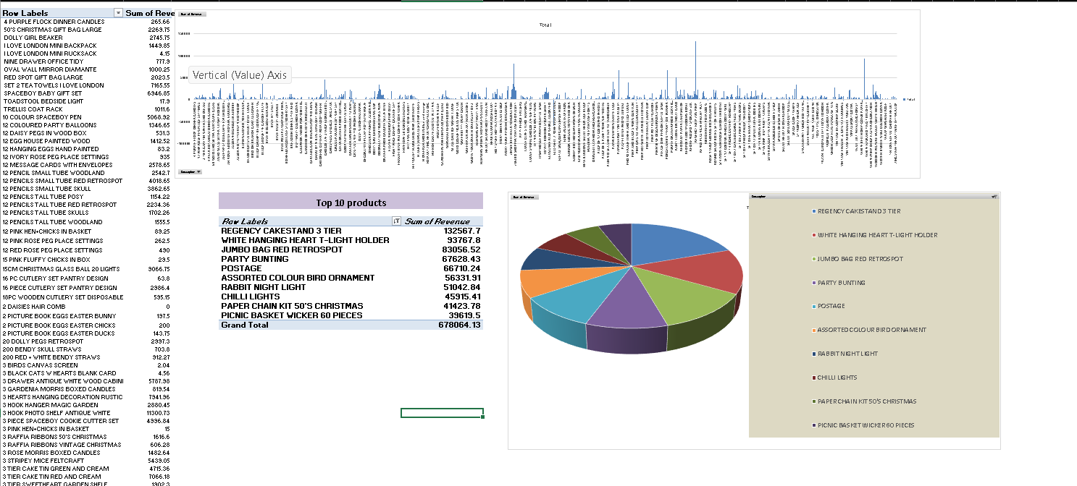

- The top 10 customers contribute revenue of 1368640.64 rupees which is 16.5% of total revenue and customer bearing customer ID 14646 has contributed around 279489.02 rupees which is 3.3% of total revenue

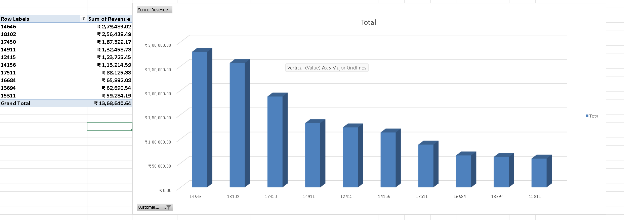

- Sales peaked in the month of November 2011 which shows strong seasonality in Q4 of 2011

